49M
JERZEES
100% Cotton Sleeveless
T-Shirt

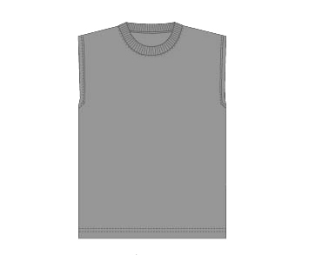

Descriptions
*100% Cotton, 5.6 Ounce jersey
*20 Singles
*Ribbed neck
*Pre-Shrunk
*Double needle stitched collar, armholes & hem
*Embroidery and screenprinting okay

Finished Garment Measurements

Size | S | M | L | XL | 2XL | 3XL
Width | 19 | 21 | 23 | 25 | 27 | 29
Length | 28 | 29 | 31 | 32 | 33 | 34
Neck Opening | 19 | 20 | 21 | 22 | 23 | 24

