P360
Hanes
Comfortblend

Youth Crewneck Sweatshirt

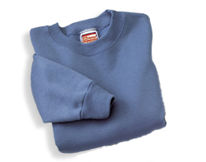

Descriptions
*50/50 poly cotton 7.8 ounce Printpro fleece
*Coverseamed neck
*Set in sleeves
*Embroidery or screenprinting okay

Finished Garment Measurements

Size | XS | S | M | L
Width | 12 | 14 | 16 | 18
Length | 17 ½ | 20 | 22 ½ | 24 ½
Sleeve Length | 20 1/8 | 23 1/8 | 26 5/8 | 29 5/8

